**JAYPEE UNIVERSITY OF ENGINEERING & TECHNOLOGY** Accredited with Grade-A+ by NAAC & Approved U/S 2(f) of the UGC Act,1956 A.B. Road, Raghogarh, District Guna (MP), India, Pin-473226 

Phone: 07544 267051, 267310-14, Fax: 07544 267011

Website: www.juet.ac.in

**Weekly Progress Report**

**Week No. _5__**

Name: Sapeksh Pareek Enrolment No. 211B274 . Period: 17/06/2024 to 23/06/2024 . Work done during Week (in detail)

This week, I undertook the task of creating a comprehensive website similar to a landing page for marketing purposes, focusing on an app (details withheld due to NDA). Leveraging my knowledge of MUI, I designed and implemented the entire website template. Additionally, I engaged in copywriting by crafting five versions of the HERO section for A/B testing, aiming to optimize user engagement. Furthermore, I developed a blogs page and authored articles related to the website's marketing strategy to enhance SEO performance. This project allowed me to integrate frontend design, copywriting skills, and SEO practices effectively.___________________________________________________

Section/Department of Organization (Under which training is going on)   
  
Drive traffic to the newly created website using digital marketing strategies. Set up a Facebook page, run ads, optimize their performance, and aim to attract significant visitor numbers._________________________________________

Name of Supervisor: Ms. Anahita Zahl Tantra (HR, Yardstick)

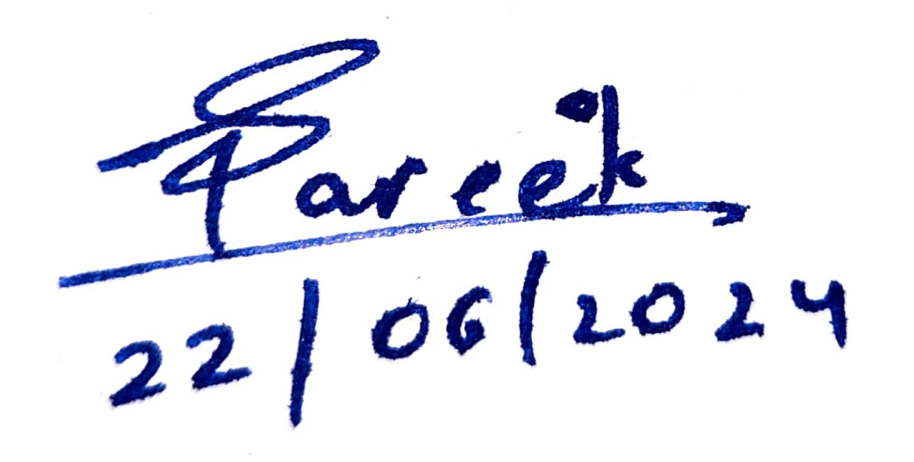

**Signature of Supervisor Signature of Student  
(with date) (with date)**